

WOMEN SAFETY DEVICE USING GPS TRACKING AND ALERTS

A MINI PROJECT

REPORT

SUBMITTED BY

BHARATH B-1NH18EE006

NANDEESH K V-1NH18EE023

SUSHMA M-1NH19EE403

*In partial fulfilment for the award of the degree of*

BACHELOR OF ENGINEERING

IN

ELECTRICAL AND ELECTRONICS ENGINEERING



BONAFIDE CERTIFICATE

This is to bonafide that the mini project report entitled “IoT BASED SMART ENERGY METER” submitted by BHARATH B(1NH18EE006), NANDEESH K V(1NH18EE023) and SUSHMA M (1NH19EE403) Department of Electrical Engineering, New Horizon College of Engineering, Bangalore in partial fulfilment for the award of the degree of bachelor of engineering, is a record of bonafide work carried out by him/her under my supervision, as per the NHCE code of academic and research ethics.

The contents of this report have not been submitted and will not be submitted either in part or in full, for the award of any other degree or diploma in this institute or any other institute or university. The project report fulfils the requirements and regulations of the institution and in my opinion meets the necessary standards for submission.

Project Guide HOD-EEE

Dr. Prabhakaran N Dr. Mahesh M



ACKNOWLEDGEMENT

We are grateful to the chairman of New Horizon Educational institution, Dr. Mohan Manghnani for motivating us to carry out research in NHCE and for providing us with infrastructural facilities and many other resources needed for our project work.

With immense pleasure and deep sense of gratitude, we wish to express our sincere thanks to our supervisor Dr.Prabhakaran N, New Horizon College of Engineering, without his motivation and continuous encouragement, this mini project would not have been successfully completed.

We wish to extend our profound sense of gratitude to our parents for all the sacrifices they made during our project and providing us with moral support and encouragement whenever required.

Date: 30/01/2021

Place: Bangalore

By:

Bharath B

Nandeesh K V

Sushma M

LIST OF FIGURES

|  |  |  |
| --- | --- | --- |
| S.No | DESCRIPTION | Page No |
| Fig 1 | Image of violence against women | Page – 7 |
| Fig 2 | Block diagram of Embedded System | Page – 8 |
| Fig 3 | Embedded system application | Page - 10 |
| Fig 4 | Circuit Diagram | Page–11 |
| Fig 5 | Arduino uno | Page – 13 |
| Fig 6 | Arduino uno pinout diagram | Page - 14 |
| Fig 7 | SIM900 Modem | Page – 15 |
| Fig 8 | NEO-6M GPS Module | Page – 15 |
| Fig 9 | SOS button | Page – 16 |
| Fig-10 | Battery | Page-17 |
| Fig -11 | Breadboard | Page-18 |
| Fig -12.1 | Jumper wires(female to female) | Page -19 |
| Fig 12.2 | Jumper wires(male to female) | Page -19 |
| Fig 13 | Resistors | Page-20 |
| Fig 14 | Buzzer | Page -21 |
| Fig 15 | Women safety | Page- 22 |
| Fig 16 | Expected model of project | Page -23 |
| Fig 17 | Expected output | Page -23 |

TABLE OF CONTENTS

1.ABSTRACT

2.INTRODUCTION

3.CIRCUIT DIAGRAM

4.COMPONENTS REQUIRED

5.COMPONENTS DESCRIPTION

6. METHODOLOGY

7. CODE FOR ARDUINO

8. Advantages and Disadvantages

9. APPENDICES

10.BIBLIOGRAPHY

1.ABSTRACT

In light of the present situation of the metro cities and other big cities , women security has emerged as one of the most important requirements in our country. In this world of advanced technology and smart electronics . It is required to have simple and cost effective safety gadget that helps the victim during unforeseen dangers . The device consists of switch, microcontroller(ATmega328p),GSM module(SIM900),GPS module(NE0-6M).The main working of this project is that anytime a women senses danger , all she has to do is to hold on the button of the device. Once the device is activated ,it tracks the place of the women using GPS(Global positioning system) and sends emergency messages using GSM(Global System for Mobile communication), to already registered mobile number and police control room.

2.INTRODUCTION

2.1. OBJECTIVE

Security is the state for constantly secured against peril or passing. In the all sense ,security will be an idea comparative on wellbeing. The subtlety the middle of the two may be a included accentuation looking into continuously ensured from dangers that begin starting with outside. People alternately activities that infringe upon the state for security would answerable for the rupture about security. The statement security as a rule use clinched alongside synonymous for the safety, yet all the as An specialized foul haul security implies that something not best will be secure Yet that it need been secured.



Fig 1

This system is designed with ATmega328. This project displays An ladies safety identification framework utilizing GPS Furthermore GSM modems. The framework could a chance to be interconnectedness for the ringer framework Also caution those encompassing people. Concerning illustration over .As in this detection and messaging system is composed of a GPS receiver ,Microcontroller and a GSM modem. GPS recipient gets the area majority of the data from satelites in the structure about scope Also longitude.

The Microcontoller will process the information and this processed information is passed to other user using SIM900A. The GSM modem send SMS to the concerned phone number. Suppose when an women feels that she is in danger for her self-defence she can press that sos button which is given to her. By pressing the sos button , the whole system will get activated and then this system will immediately sends an sms to registered person with latitude and longitude values using GSM and GPS.

2.2 INTRODUCTION TO EMBEDDED SYSTEMS

This microprocessor system is used to monitor a typical function or set of functions and is not intended to be programmed as an embedded system by an end-user in the same way that a PC is specified. An embedded device is designed to perform a specific role, although with numerous options and choices.

The embedded machine includes computing cores that are either optical signal processors or microcontrollers. Microcontrollers are usually referred to as a "chip" and can be bundled in a hybrid Application Specific Integrated Circuit (ASIC) device with other microcontrollers. In general, input often comes in more specific words from a detector or sensors and in the meantime the output goes to the operation.

An inserted framework may be mix of workstation fittings and product ,either settled lack of ability alternately programmable , that is particularly intended for specific sort of requisition gadget. In different sectors like industrial machines ,automobiles ,medical equipment ,vending machines and toys are among the myriad possible hosts of an Embedded system. Installed frameworks that need aid programmable need aid furnished with modifying interface , What's more inserted framework modifying programming id specialised occupation.

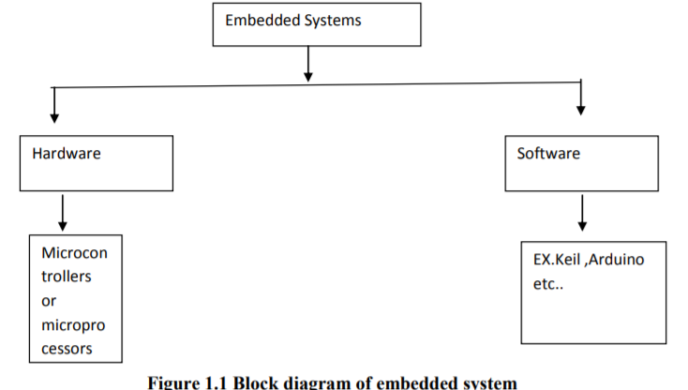

Fig -2 Block Diagram for Embedded system

The square outline for installed framework (ES comprises of both the equipment Furthermore product a piece which comprises for modifying language).

On the different hand, those microcontroller is An single silicon chip comprising of every last one of information ,output Furthermore peripherals on it. A single Microcontroller need the accompanying

Characteristics :.

1)Arithmetic and rationale unit.

2)Memory for storing system.

3)EEPROM for non-volatile Furthermore uncommon capacity registers.

4)Analog with advanced converter.

5) Input/output ports.

6) Circuit.

7)Serial correspondence ports.

2.3 APPLICATIONS OF EMBEDDED SYSTEM.

We need aid existing in the installed planet. You need aid encompassed with a number inserted results Also your Every day life generally relies on the legitimate functioning’s from claiming these gadgets ,television ,radio,CD layer about your existing our clinched alongside your kitchen. Separated from all these over ,there are a number controllers installed in our auto which fare thee well from claiming our auto operation the middle of those guard What's more for mossycup oak of the times have a tendency on overlook constantly on these controllers.

In the later days we are showered with assortment for data around these installed controllers On a number spots. Likewise we seen On the whole sort of magazines Also diaries they consistently dispense subtle elements around most recent advances which are constantly utilized for Also around the universe and which make us think that our fundamental survival is regulated Eventually Tom's perusing these installed items. Presently we camwood concur of the certainty that these installed results bring effectively attacked under our globe.

Those machines you use will create your mails , or make a record or dissect the database may be known as standard desktop machine. These desktop Pcs would made with serve a number design What's more provisions.

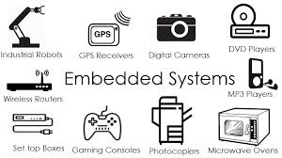

Fig 3 – Embedded system application

3. CIRCUIT DIAGRAM

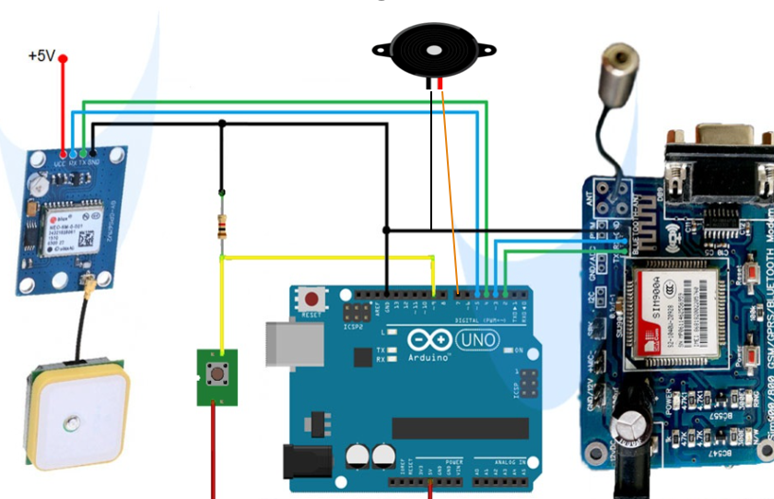

Fig-4 Circuit diagram

4.COMPONENTS REQUIRED

1. Arduino uno
2. SIM900 Modem
3. NEO6M GPS module
4. Button
5. Battery
6. Breadboard
7. Jumpers
8. Buzzer

5.COMPONENTS DESCRIPTION

5.1 ARDUINO UNO

Arduino will be essentially open source PC hardware/software stage to building advanced gadgets Furthermore intelligent media Questions that camwood sense What's more control those physical planet around them. For beginners it is precise basic to utilize Furthermore Shabby. It camwood make used to make such units that camwood connect for nature's domain utilizing sensors.

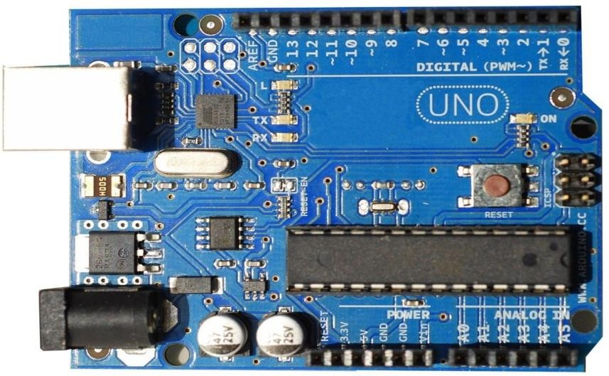

Fig- 5 Arduino Uno

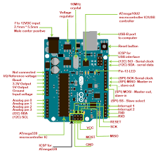

Fig 6 -Arduino uno pinout diagram

5.2 SIM900 Modem

This is An GSM/GPRS-compatible quad-band wireless ,which meets expectations looking into An recurrence for 850\900\1800\1900MegaHZ and which could be utilized to Different provisions for example, such that with get the web ,make a voice call ,send Furthermore accept SMS ,etc. Those recurrence groups of the GSM modem could a chance to be set by In commands. The baud rate is configurable from 1200-11500 through In summon. Those GSM/GPRS modem may be Hosting a inward tdt stack which empowers us should interface for the web through GPRS. This is an SMT sort module Also outlined in view of a capable chip processor coordination AMR926EJ-S core, which is verwoerd mainstream for Different streamlined results.

Technical Specifications:

1) supply voltage :3. 4v to 4. 5v.

2) control sparing mode:- rest mode control utilization =0. 5mA.

3) recurrence groups :-SIM900A double -band :EGSM900,DCS1800.

4) operating Temperature:- 30ºC should +80ºC.

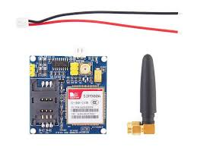

Fig 7 SIM900 MODEM

5.3 NEO6M GPS MODULE

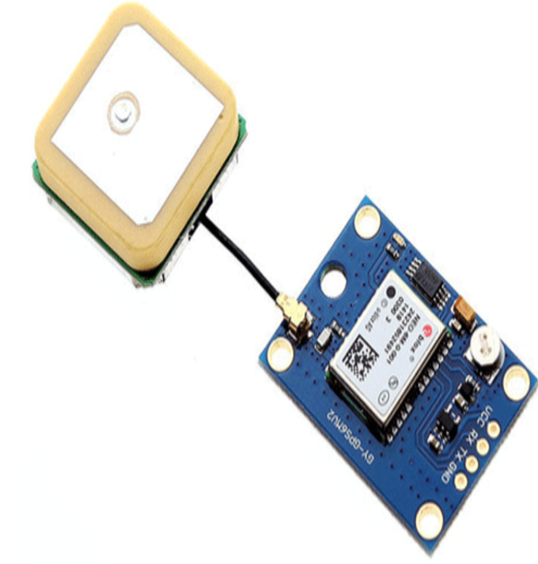

Fig 8 NEO-6M GPS module

Here we are utilizing those NEO6M GPS module. The NEO-6M GPS module will be a prominent GPS recipient with a inherent ceramic radio wire , which gives a solid satellite look ability. This collector need the capacity to sense the areas Furthermore track dependent upon 22 satellites Also identifies areas anyplace in the planet. Also Additionally for the on-board indicator indicator, we might effortlessly screen those system status of the module. It need a information reinforcement battery so that the module camwood spare the information when the fundamental control will be close down incidentally.

Those center heart inside those GPS recipient will be the NEO-6M GPS chip. Likewise it camwood track dependent upon 22 satellites around 50 channels What's more bring a amazing sensity level which is -161 dBm. This module helps the baud rate from 4800-230400 bps Also need the default baud rate for 9600.

Features:.

1. operating voltage:- (2. 7-3. 6)V dc.
2. working Current:- 67 milli Amps.
3. baud rate:- 4800-230400 bps (we use 9600 Default).
4. correspondence Protocol: NEMA
5. Interface used: UART.
6. outside radio wire Furthermore inherent EEPROM.

5.5 SOS BUTTON:

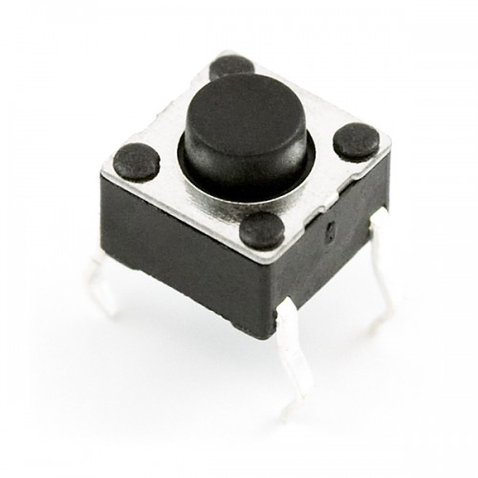

Fig- 9 SOS button

* The SOS key will allow to send SMS to concerned person like brother, father and police.
* This key should be setup to function correctly.
* For security reasons the device should be unlocked before executing this function.

5.6 BATTERY:

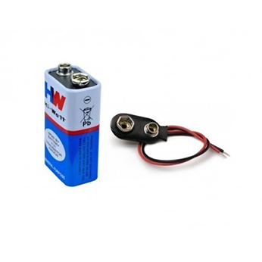

Fig- 10 Battery

Batteries are everywhere because in modern world is dependent on this portable source of energy which is found in almost all electronic components.

In our project we are using two 9V battery, one for transmitter part and other for receiver part and which intern connected to Arduino nano, GSM and GPS module.

5.7 BREADBOARD:

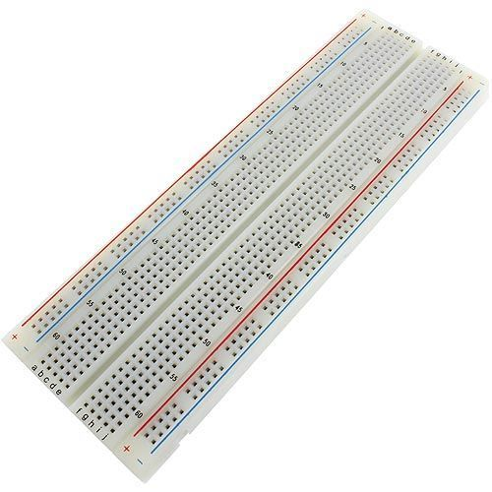

Fig- 11 Breadboard

Breadboard is a temporarily circuit for testing and even used for other purpose also. The main advantage for using this breadboard is to test the connections and it can be easily replaced when the connections wrong. The main parts of breadboard will do not get affected and also it can be reused.

Finally the breadboard is often simple and easy and as it give the results immediately which is easy for testing multiple gadgets and electronic products.

5.8 JUMP WIRE:

 Jumper will be an aggregation for electrical wire clinched alongside a cable, for An connector alternately pin during every conclusion which is typically used to interconnected those parts of a bread board or different model alternately test circuit, internally with different gear alternately segments without fastening.

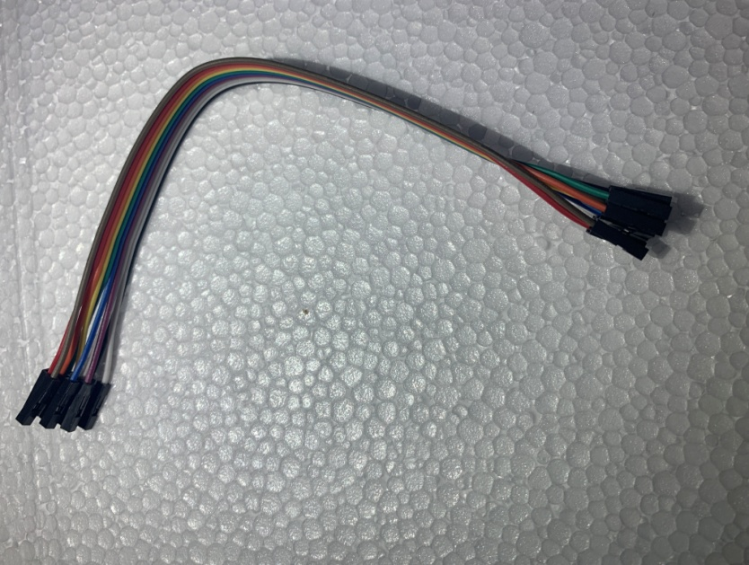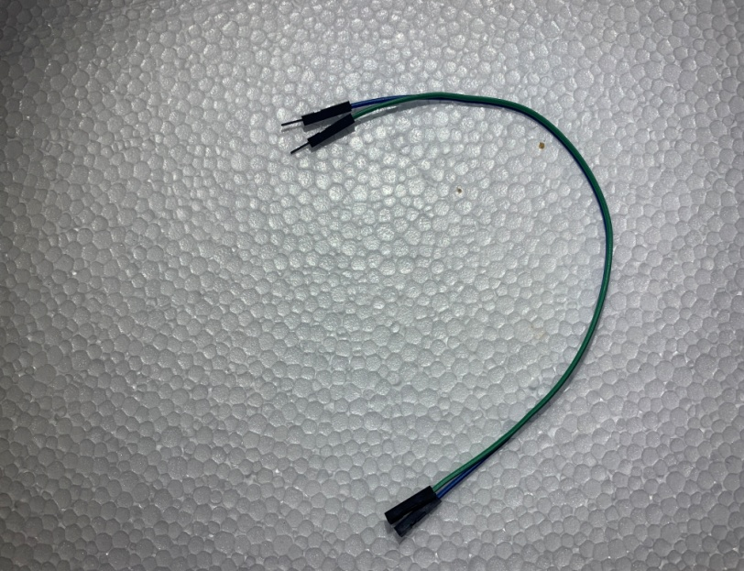

Fig 12.1 female to female Fig 12.2 female to male

There will make three sorts about jumper wire need aid.

1. Male will male jumper wire.
2. Male will female jumper wire.
3. Female should female jumper wire.

5.9 RESISTOR:

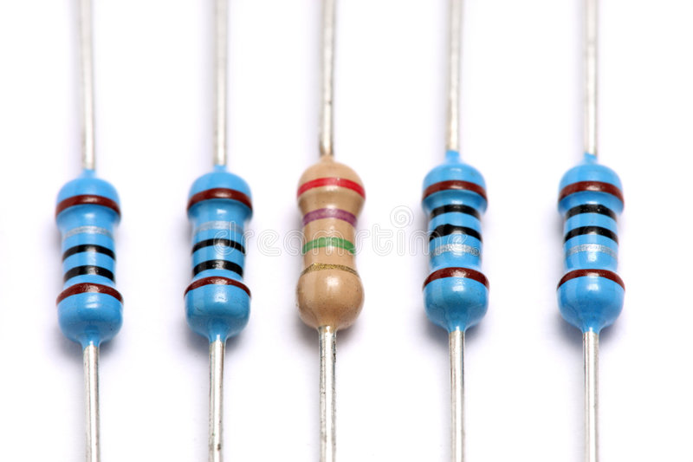

Fig – 13 Resistors

A resistor offers a resistance to the flow of current and act as voltage droppers or voltage dividers. They are Passive Devices, that is they contain no source of power or amplification but only attenuates or reduces the voltage signal passing through them. For high current operations resistance of higher current ratings are used. Resistance is nothing but the hindrance that a substance offers to the flow of electric current and it is represented by ‘R’. The standard unit of resistance is ohm.

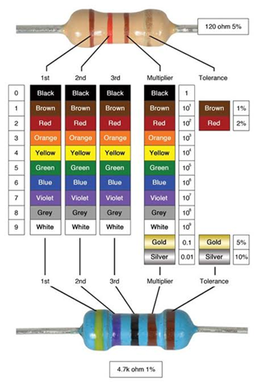In our project we are using 1K ohm resistor

5.10 BUZZER:

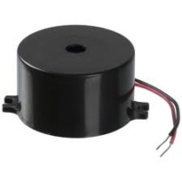

Fig-14 Buzzer

* The buzzer which adds a beep sound to our project. It is an audio signalling device
* It has two pins which is given to power supply and other pin to ground.
* By changing frequency of buzzer will change its speed results in forming vibrations which resulting sound.

6.METHODOLOGY

In this model we are using Arduino UNO, GSM module SIM900A, GPS module, Buzzer and SOS button.

Make the connections as per the circuit diagram. Then check the code in the Arduino ide and verify it and if no erorrs then compile and upload that code into Arduino uno. The GPS recipient obtains those information in general NMEA configuration content. Just the scope Furthermore longitude coordinates need aid made from it; utilizing those Arduino TinyGPS library.. When if person presses the SOS button , Then the GSM module which will send an SMS to number mentioned in the code and also will be displaying the latitude and longitude of the concerned person by stating that she is in danger and in need of help urgently.

If any unusual thing happening around women can press that SOS button so this system will send the location to concerned person.

In case of emergency this system will produce a beep sound by this way the surrounding people may come for help.



Fig – 15 Women safety

EXPECTED OUTPUT RESULTS

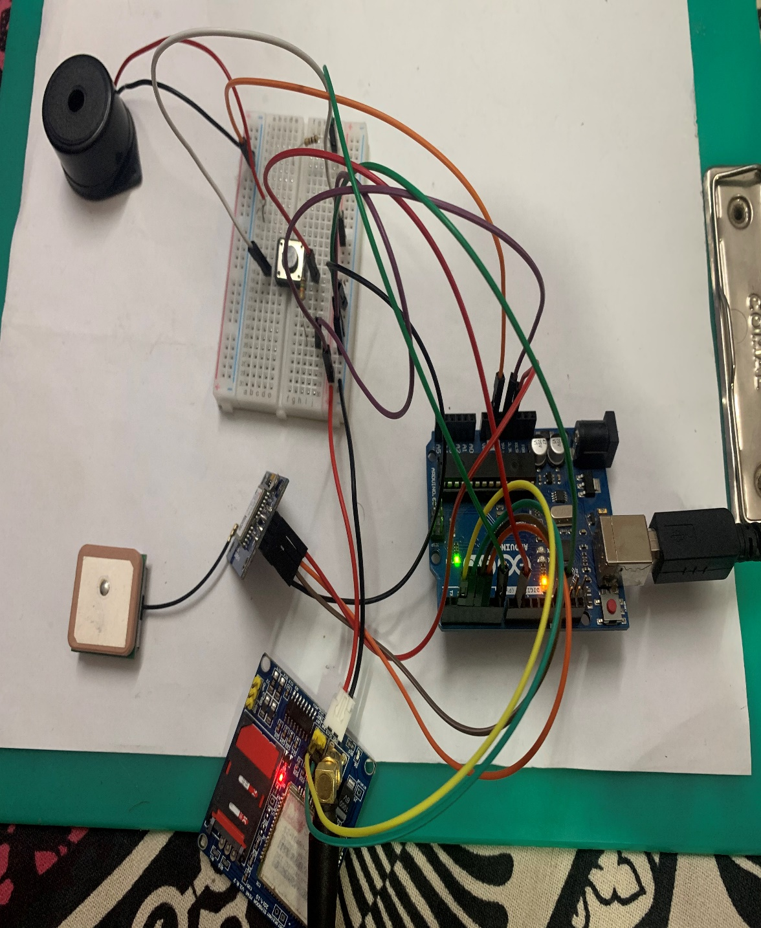 Fig -16

The SMS sent will be shown below

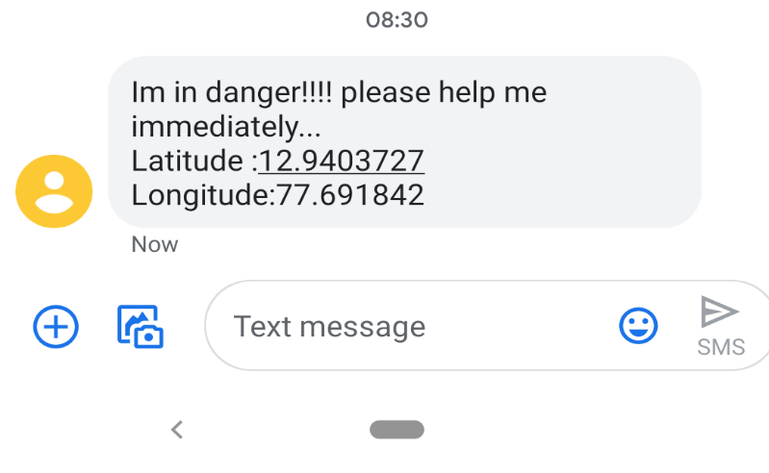

Fig - 17

7.CODE FOR ARDUINO:

#include <SoftwareSerial.h>  
#include <TinyGPS.h>  
  
int state = 0;  
const int pinBuz = 7;  
const int pin = 9;  
float gpslat, gpslon;  
  
  
TinyGPS gps;  
SoftwareSerial sgps(4, 5);  
SoftwareSerial sgsm(2, 3);  
  
void setup()  
{  
  sgsm.begin(9600);  
  sgps.begin(9600);  
  pinMode(pinBuz,OUTPUT);  
}  
  
void loop()  
{  
sgps.listen();  
  while (sgps.available())  
  {  
    int c = sgps.read();  
    if (gps.encode(c))  
    {  
      gps.f_get_position(&gpslat, &gpslon);  
    }  
  }  
    if (digitalRead(pin) == HIGH && state == 0) {  
      noTone(pinBuz);  
      delay(1000);  
      sgsm.listen();  
      sgsm.print("\r");  
      delay(1000);  
      sgsm.print("AT+CMGF=1\r");  
      delay(1000);  
      sgsm.print("AT+CMGS=\"+918073910441\"\r");  
      delay(1000);  
      sgsm.println("Im in danger!!!! please help me immediately...");  
      sgsm.print("Latitude :");  
      sgsm.println("12.9403727");  
      sgsm.print("Longitude:");  
      sgsm.println("77.691842");  
      delay(1000);  
      sgsm.write(0x1A);  
      delay(1000);  
      tone(pinBuz,1000);  
      delay(1000);  
      state = 1;  
       
    }  
  if (digitalRead(pin) == LOW) {  
      state = 0;  
      digitalWrite(pinBuz,0);  
    }  
  }

8.ADVANTAGES AND DISADVANTAGES

ADVANTAGES:

1. We can easily track Victim’s location
2. This system is affordable and not so expensive

DISADVANTAGES

1. Heavy in size
2. This will not give proper output if connections are loose
3. To track women’s location mobile network is must

9.CONCLUSION

Likewise presently 86% for working ladies in India, ladies confronting obstructions Furthermore security issues. Previously, Delhi, Maharashtra, Hyderabad, kolkata What's more Pune relatively on different spots.

In this territory from claiming provision for further Look into What's more advancement ,this project might make executed in distinctive zones of security Also reconnaissance.

For those help from claiming this framework we camwood perform the constant checking from claiming wanted territory Furthermore recognize the brutality happening for a great precision.

10.APPENDICES

|  |  |
| --- | --- |
| ABSTRACT | PAGE 6 |
| ACKNOWLEDGEMENT | PAGE 3 |
| INTRODUCTION | PAGE 7 |
| CIRCUIT DIAGRAM | PAGE 11 |
| COMPONENTS REQUIRED | PAGE 12 |
| COMPONENTS DESCRIPTION | PAGE 13-21 |
| METHODOLOGY | PAGE 22-23 |
| CODE FOR ARDUINO AND NODMCU | PAGE 24-25 |
| ADVANTAGES AND DISADVANTAGES | PAGE 26 |
| CONCLUSION | PAGE 27 |
| BIBLIOGRAPHY | PAGE 29 |

11. BIBLIOGRAPHY

<https://circuitdigest.com/microcontroller-projects/arduino-based-women-safety-device-for-emergency-alert-and-tracking>

<http://www.kscst.iisc.ernet.in/spp/42_series/41S_awarded_&_selected_projs_further_devpt/41S_BE_2792.pdf>

https://www.ripublication.com/irph/ijict_spl/ijictv4n8spl_01.pdf